CALL TO ORDER: 7:26PM
Trustees: Jeff Haenggi – Trustee, Katie Gossman – Treasurer, Michael Seeds – Clerk were present for the meeting.

Presentation to Citizens of Proposed 2020 Budget: (~recording mark 00:15)
Trustee Haenggi presented the 2020 Budget. Due to the damage from the storms in Sept/Oct of 2018 not being reimbursed by FEMA and the unexpected ferocity of the April/May 2019 storms (which should be reimbursed, but funds probably won't be received until 2020) the Board has decided it is unfortunately necessary to raise the mill levy from 14.998 to 16.687. This will increase our estimated 2020 Ad Valorem taxes from $489,731 to $541,005 (+$51,274). Based on projected rising property values this is only an increase, on average, of $24.40 per taxable entity in the township (households, farmland and businesses).

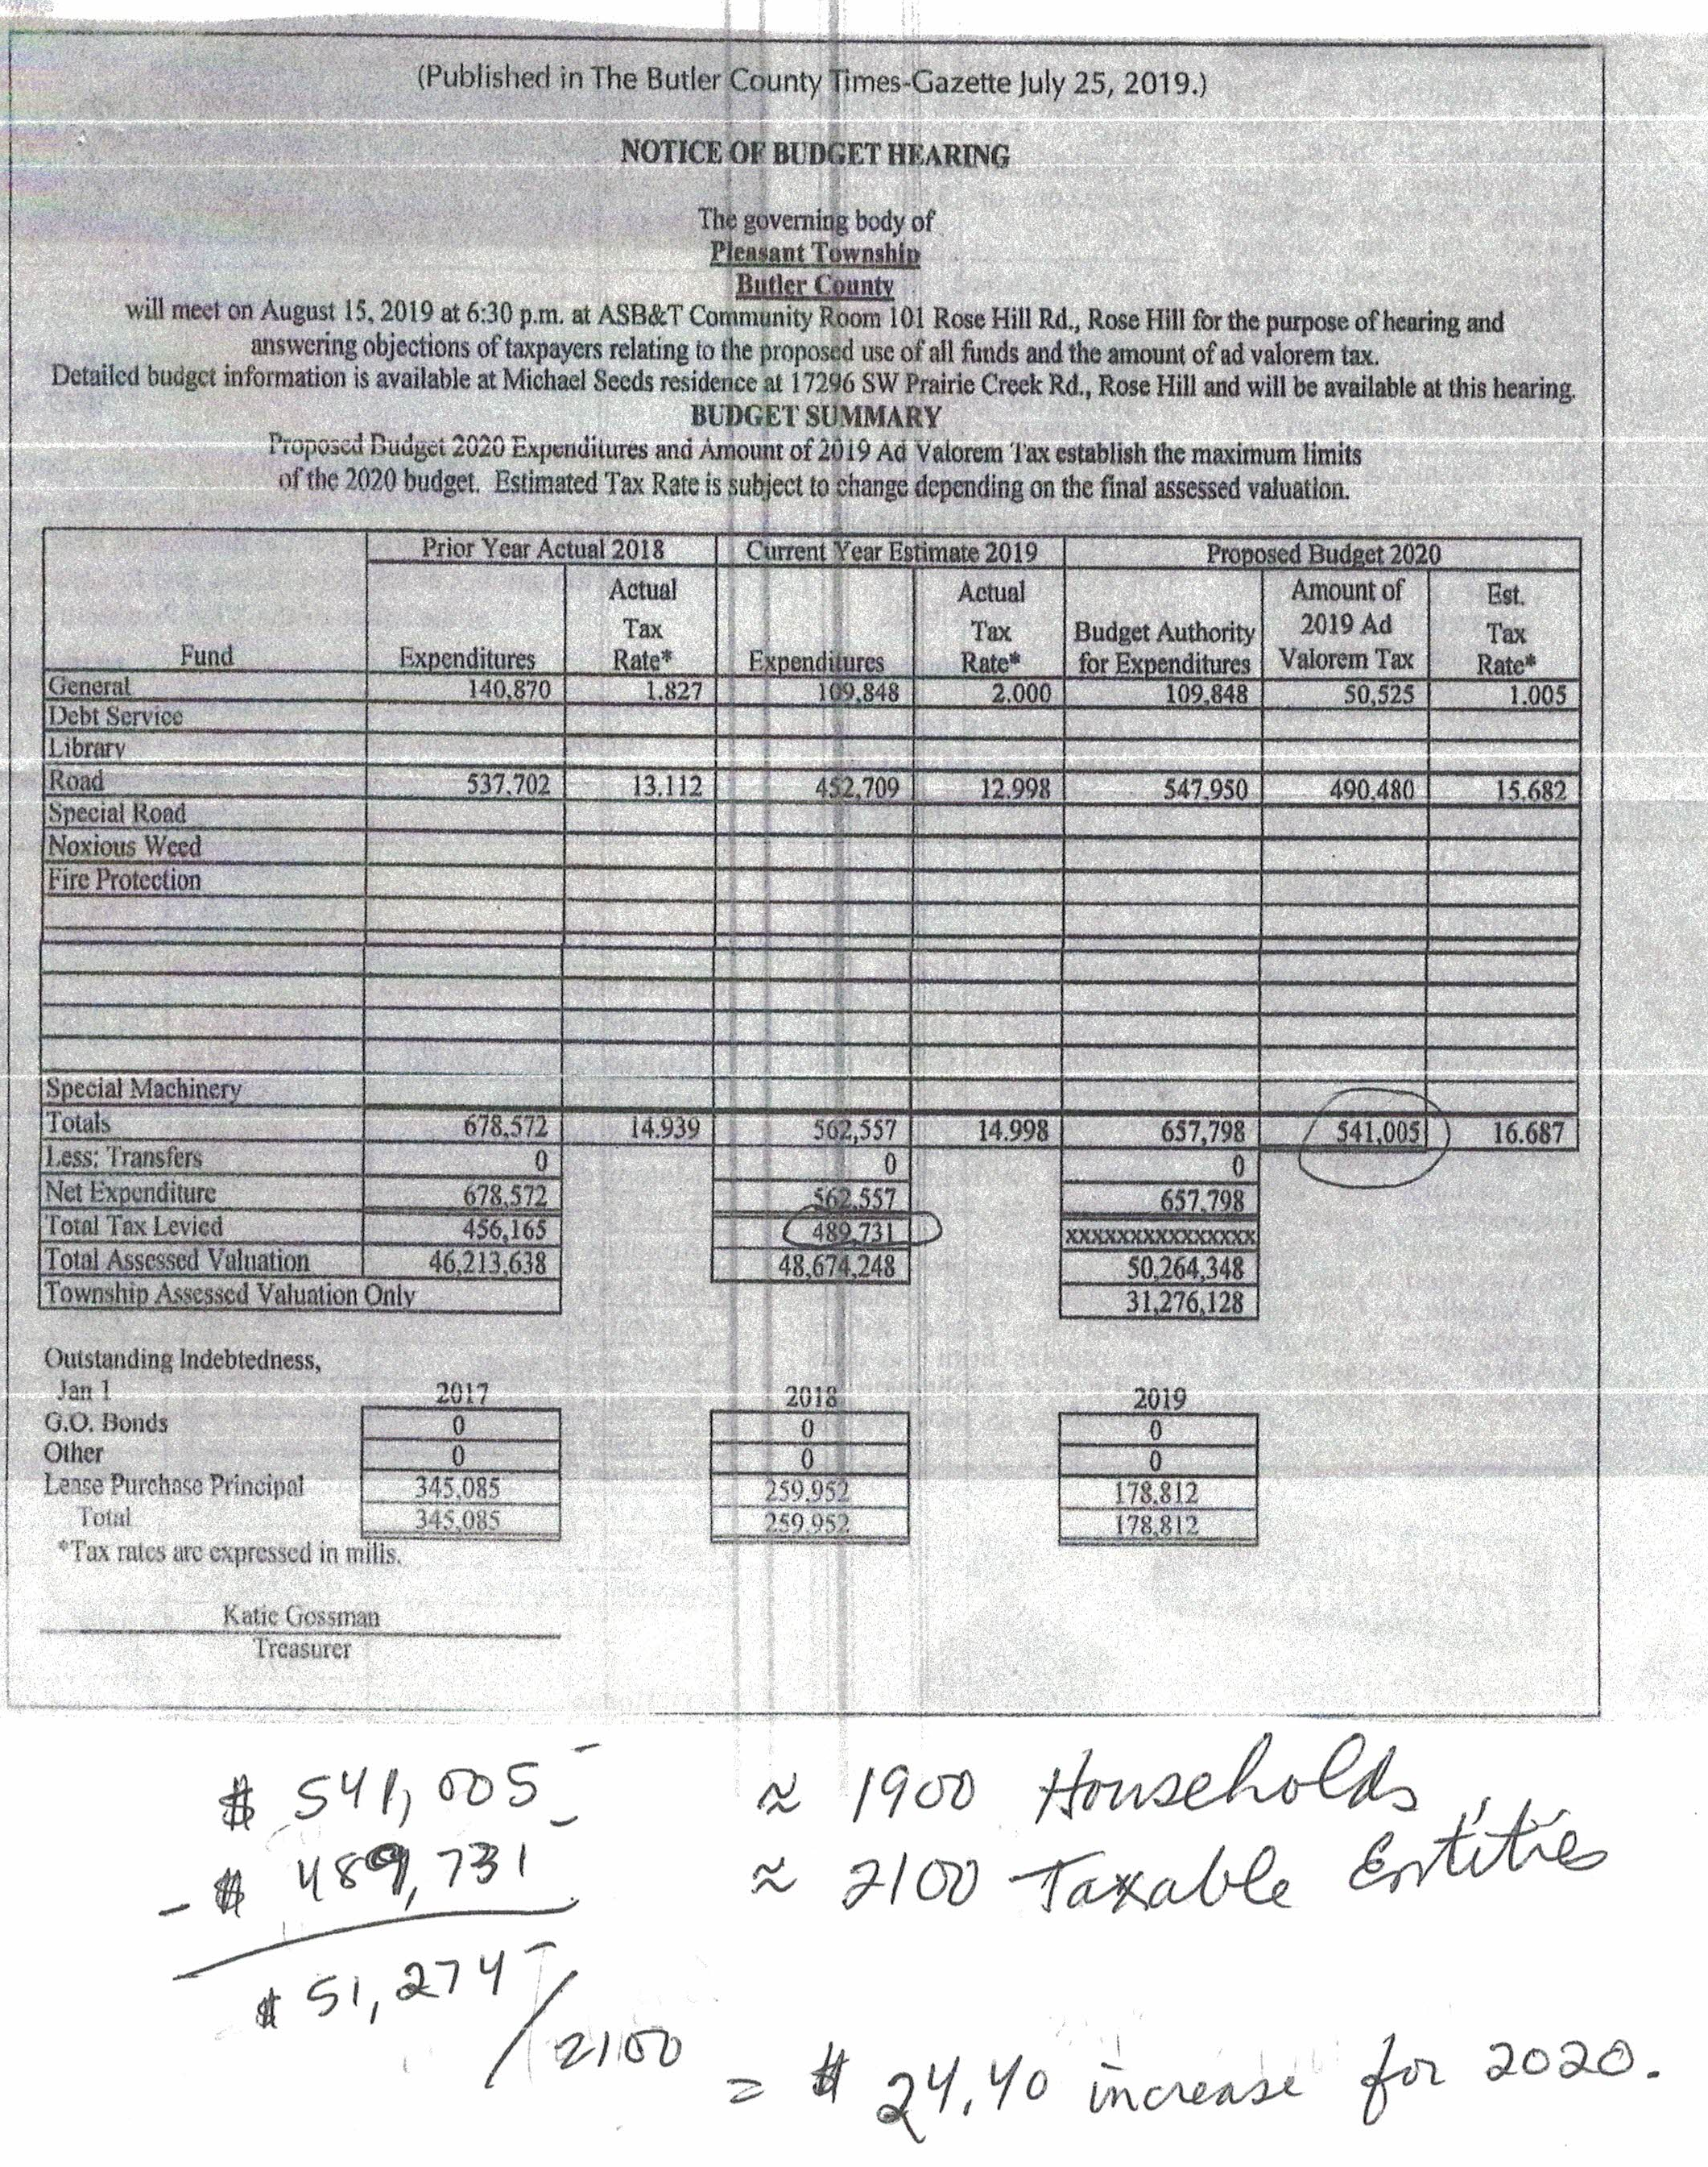

BOARD BUSINESS: (~recording mark 3:50)
1. | 2020 Budget Adoption | VOTE 3:0 For

ADJOURNMENT:
Meeting adjourned at 7:31PM

